READ ME

ADVAIT AHIR

https://people.ucsc.edu/~aahir/163/HW1/

A)

https://people.ucsc.edu/~aahir/163/HW1/Homework1Num1.html

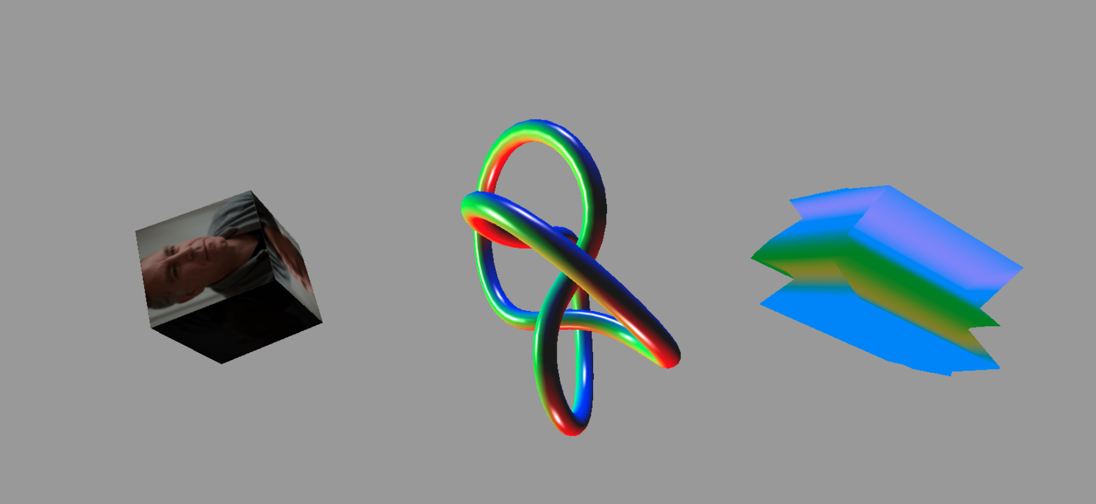

B)

https://people.ucsc.edu/~aahir/163/HW1/Homework1Num2.html

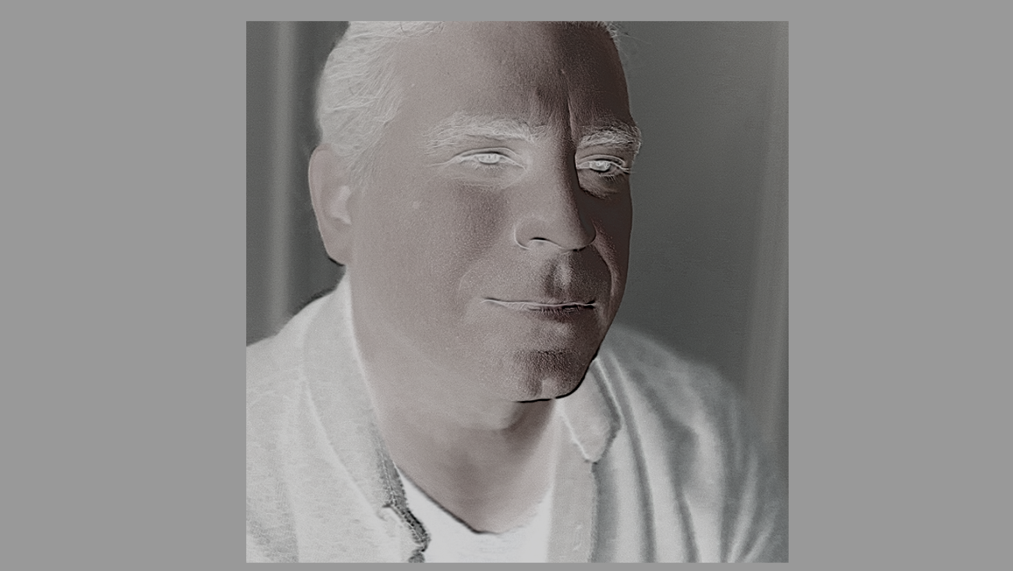

C)

https://people.ucsc.edu/~aahir/163/HW1/Homework1Num3.html

